***Assignment 7.1***

Task Description #1 (Syntax Errors – Missing Parentheses in Print  
Statement)  
Task: Provide a Python snippet with a missing parenthesis in a print  
statement (e.g., print "Hello"). Use AI to detect and fix the syntax error.  
# Bug: Missing parentheses in print statement  
def greet():  
print "Hello, AI Debugging Lab!"  
greet()  
Requirements:  
• Run the given code to observe the error.  
• Apply AI suggestions to correct the syntax.  
• Use at least 3 assert test cases to confirm the corrected code  
works.

**Prompt:** Correct this code without any errors

**Code and Output:**

Error Code:

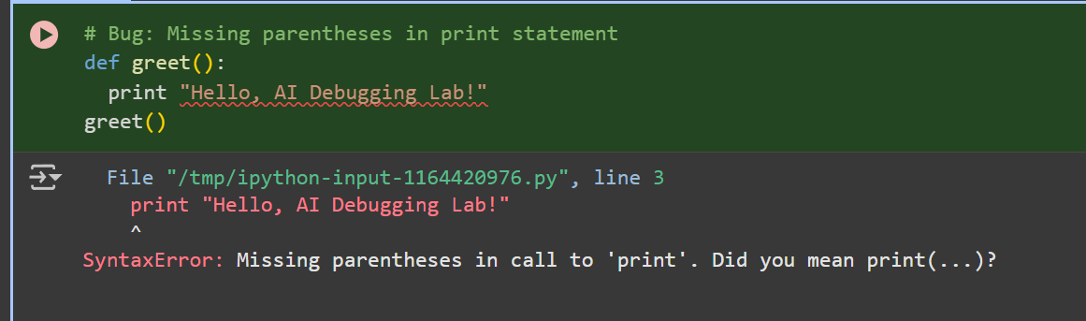

Corrected Code:

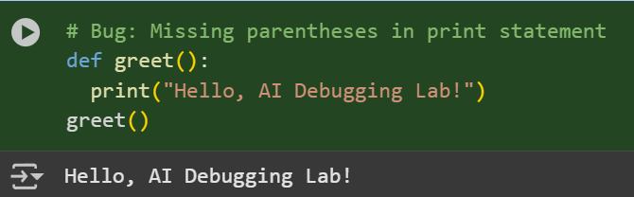

**Observation:**

In this code we can Observe that the code we have entered is wrong and it is corrected by the AI

Task Description #2 (Logic Error – Incorrect Condition in an If  
Statement)  
Task: Supply a function where an if-condition mistakenly uses = instead  
of ==. Let AI identify and fix the issue.  
# Bug: Using assignment (=) instead of comparison (==)  
def check_number(n):  
if n = 10:  
return "Ten"  
else:  
return "Not Ten"

Requirements:  
• Ask AI to explain why this causes a bug.  
• Correct the code and verify with 3 assert test cases.  
Expected Output #2:  
• Corrected code using == with explanation and successful test  
execution.

**Prompt:** Correct the Given code without any Errors

**Code and Output:**

Error code;

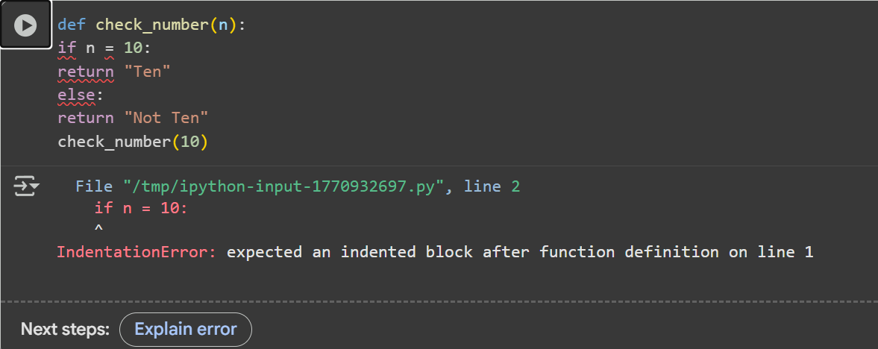

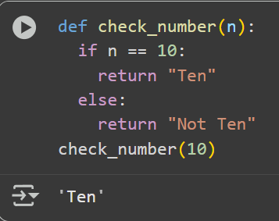Corrected Code:

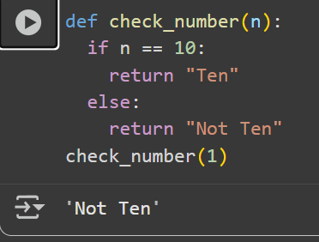

**Observation**: In this Code we can Observe that the code of Check whether the Given Number is 10 or not code is corrected by the AI

Task Description #3 (Runtime Error – File Not Found)  
Task: Provide code that attempts to open a non-existent file and crashes.  
Use AI to apply safe error handling.  
# Bug: Program crashes if file is missing  
def read_file(filename):  
with open(filename, 'r') as f:  
return f.read()  
print(read_file("nonexistent.txt"))  
Requirements:  
• Implement a try-except block suggested by AI.  
• Add a user-friendly error message.  
• Test with at least 3 scenarios: file exists, file missing, invalid  
path.  
Expected Output #3:  
• Safe file handling with exception management.

**Prompt:** Correct the Given Code By creating New file and Adding content to it and print the Content in the File

**Code and Output:**

Error Code:

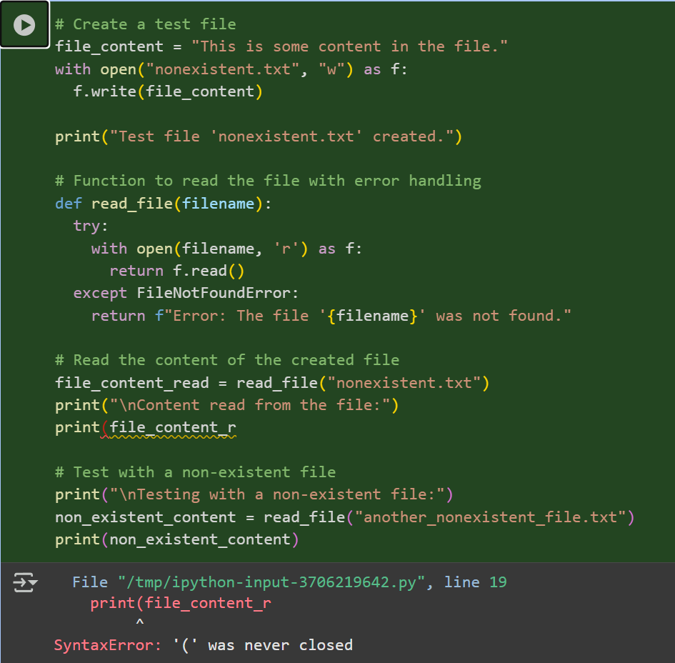

Corrected code:

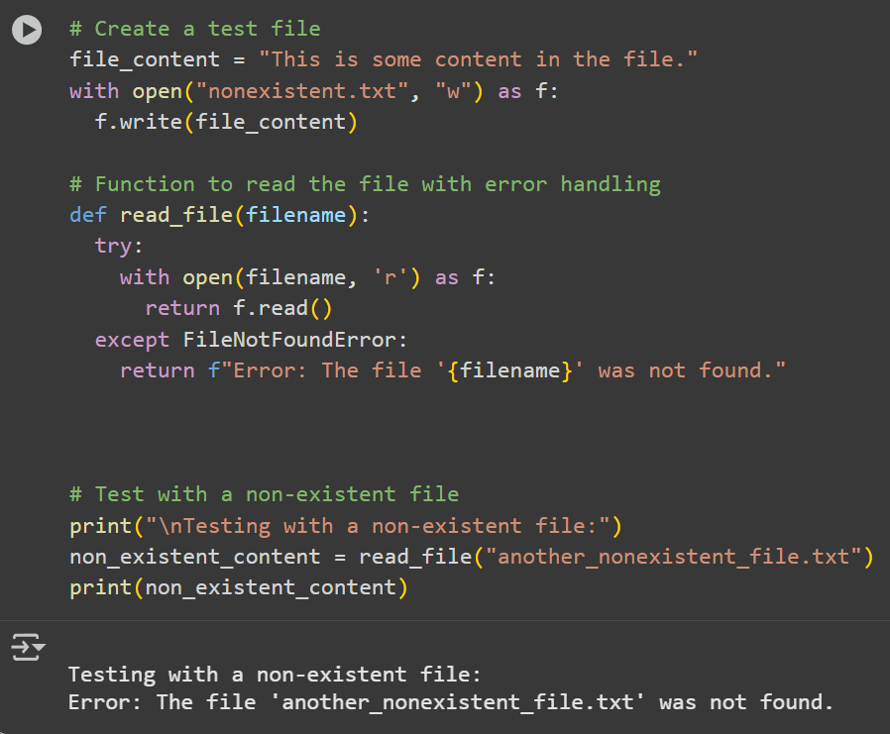

-

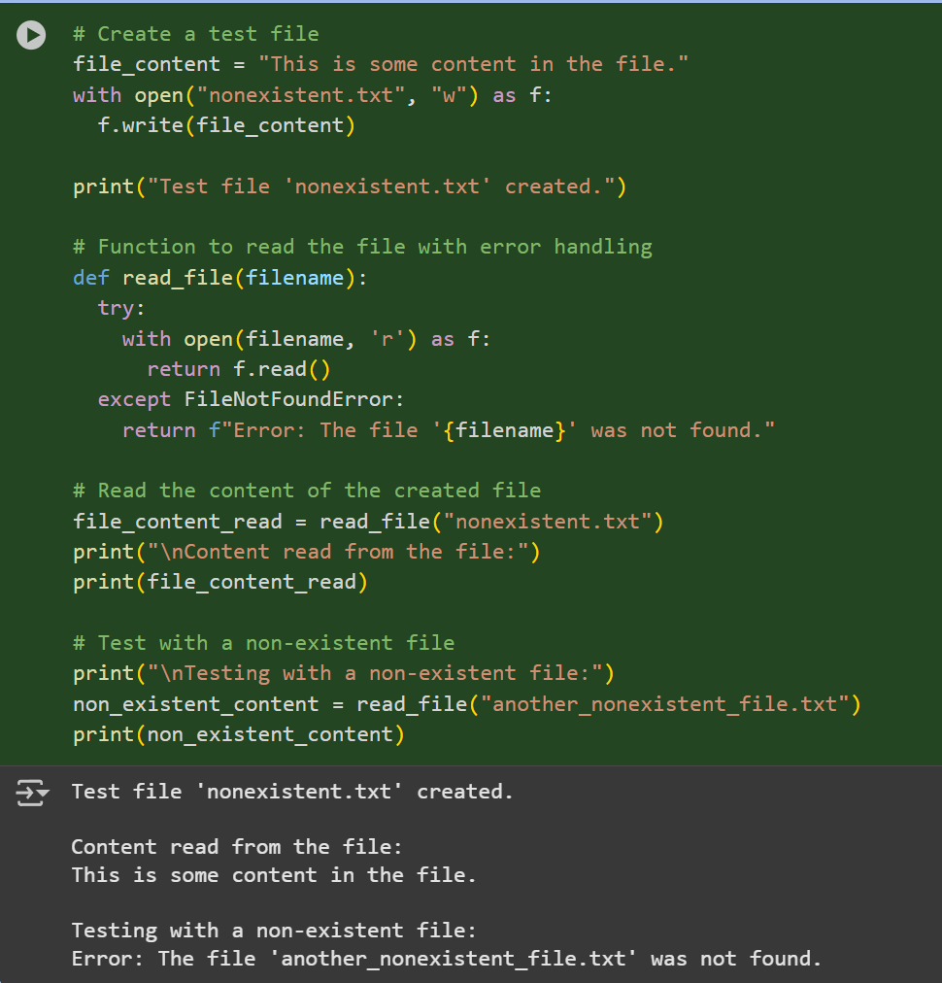

**Observation:**

In this Code we can Observation that the code is Corrected By the AI and Not it can read the file content by creating a file and adding the content into the file and print the Content

Task Description #4 (AttributeError – Calling a Non-Existent Method)  
Task: Give a class where a non-existent method is called (e.g.,  
obj.undefined_method()). Use AI to debug and fix.  
# Bug: Calling an undefined method  
class Car:  
def start(self):  
return "Car started"  
my_car = Car()  
print(my_car.drive()) # drive() is not defined  
Requirements:  
• Students must analyze whether to define the missing method or  
correct the method call.  
• Use 3 assert tests to confirm the corrected class works.  
Expected Output #4:  
• Corrected class with clear AI explanation.

**Prompt:** Correct the Code and print the Output by the corrected Code

**Code and Output:**

Error Core:

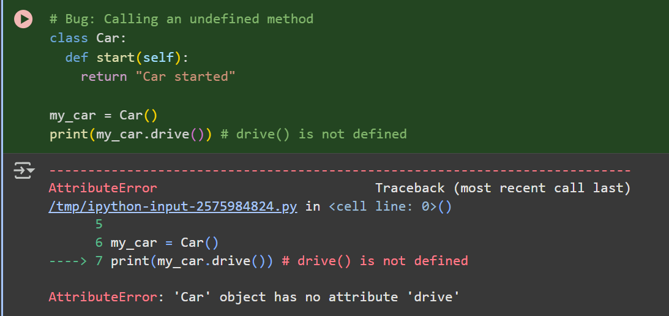

Corrected Code:

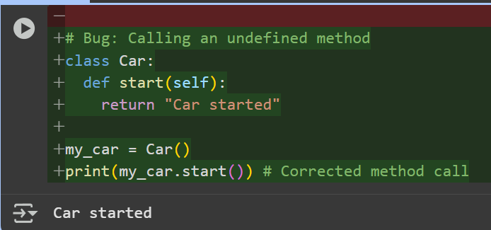

**Observation**:In this code we can Observe that the code is getting corrected by the Ai and It is correcting The code

Task Description #5 (TypeError – Mixing Strings and Integers in  
Addition)  
Task: Provide code that adds an integer and string ("5" + 2) causing a  
TypeError. Use AI to resolve the bug.  
# Bug: TypeError due to mixing string and integer  
def add_five(value):  
return value + 5  
print(add_five("10"))  
Requirements:  
• Ask AI for two solutions: type casting and string concatenation.  
• Validate with 3 assert test cases.  
Expected Output #5:  
• Corrected code that runs successfully for multiple inputs

**Prompt;**

**Code and Output:**

Error Code:

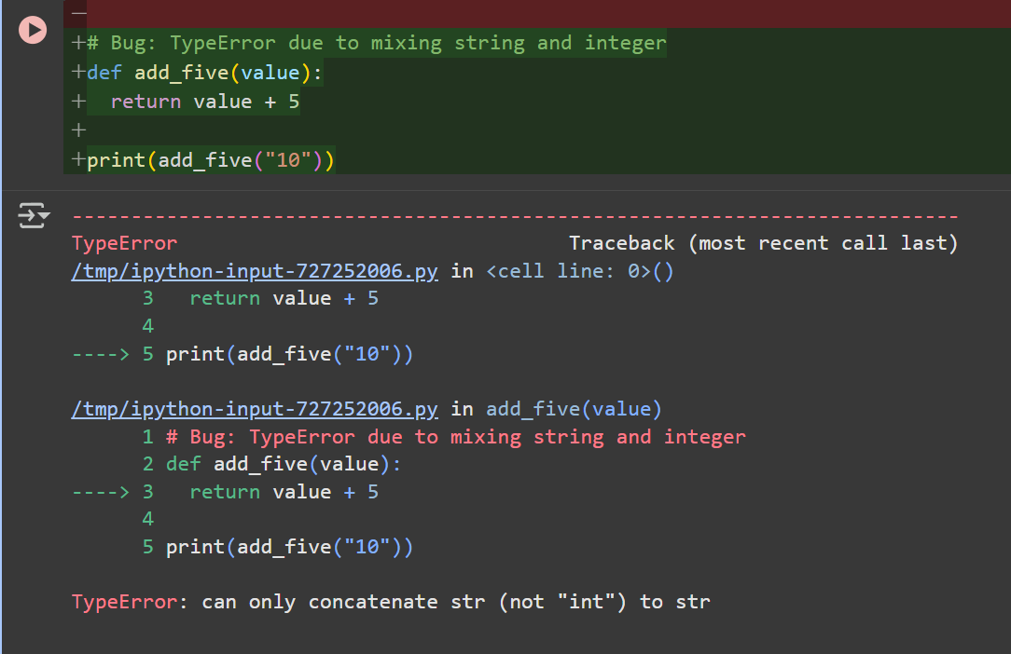

Corrected Code:

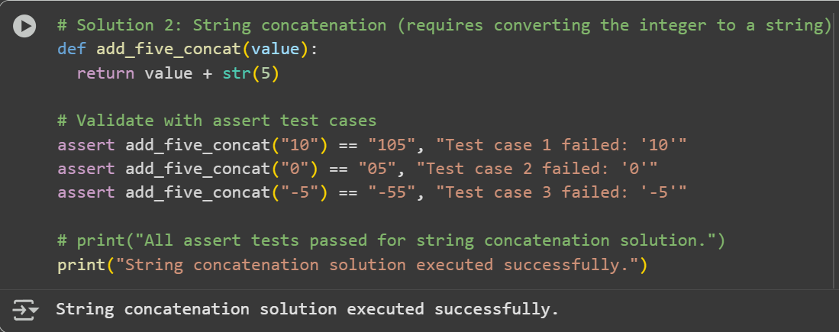

**Observation**: In this code we can see that the code Is corrected by the AI and passed all the Test cases